﻿Assignment: Transformer Language Models

Check when is the first row in the sampling which is identical to some row in the train data. Then takes

1. We quickly noticed that we could achieve arbitrarily low loss after enough training batches. So, a big challenge was achieving low loss while not over fitting. **First**, via continuous sampling, we noticed that networks with low enough loss are returning sentences from the training data, not generating new ones. (Side note: we changed the prompt from “hello” to “my lord” for the Shakespeare segment). **secondly**, we tried splitting the data to test and train parts, this enabled us to visually see the overfit. The graph below shows the loss on the train data vs the loss on the tests data, expressing the perplexity of the model on the test data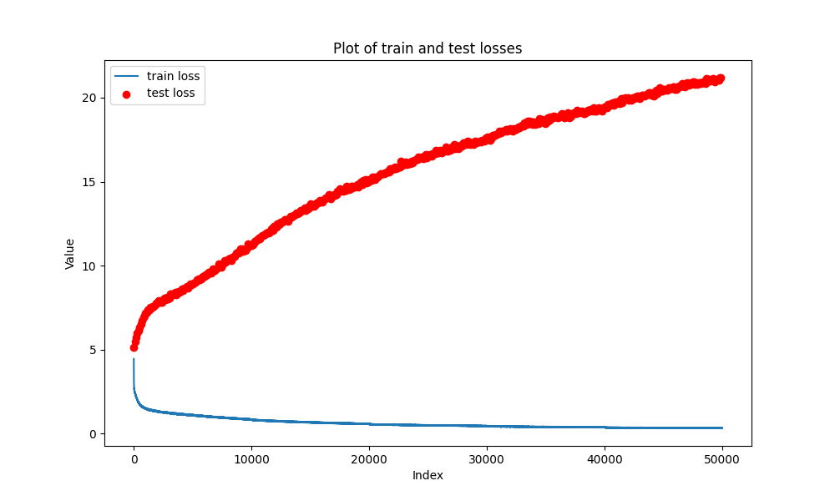

We concluded that in the scope of this work we did not have enough tools to determine a stopping point for all train scenarios. In the baseline experiments, the sampling (done with *better sampling* suggested practices) was stable and made sense after training on 7500 batches of 128 samples in each batch with sequence length of 128, summing to seeing 122,880,000 characters. Since arbitrarily low loss cound be achieved, we chose 122,880,000 characters point to be our stopping point for training.

**Our best results of loss 0.42 (with the shakespear data) were thus achieved after 7500 batches, with a network with 5.42 million parameters. It comprised of with batch size of 128, 12 layers, 6 attention heads, 192 embedding dimension size (and 768=4*hidden dim size of hidden MLP layer size), schedueler for the learning rate and weight decay usage of 0.01.**

See loss curve for shakespear data (we got the model from the 7500 mark):



Again we remind that we could get arbitrarily low loss after enough epochs, but overfit and quality of sampling guided us to choose this model.

1. 1. Experiments with **heads** number of 4,6,8,12,16. 6 heads showed the best loss at the stopping point. Also, with 8, 12, 16 heads we saw bad results in the sampling, producing words with wrong spelling and also higher loss. Thus, we chose 6 to be the head number.
   2. Experiments with layers number of 6, 12, 24. 12 layers produced the best loss, yet all produced high quality sampling. Thus we chose 12 to be the layer number.
   3. Experiments with embedding dimensions of 192, 252, 480. 480 embedding showed the lowest loss at the stopping point with 0.3 loss, but the sampling results showed spelling mistake and non-comprehendible text. Dimension size 252 also showed bad sampling results, although showing low loss. We concluded using 192 as embedding dimension size.
2. Improvements:
   1. We added Xavier Glorot normal initilization for all matrix parametrs. This helped convergence.
   2. We added weight decay of rate 0.01.
   3. We added shcedueler for learning rate auto adjustment.
   4. We increased batch size to 128, this improved loss. Also, we tested higher batch size but the affect was not significant.
   5. We tried adding dropout layers as suggested but we found out that using weight decay and scheduler yielded better results and adding dropout layers on top of these components damaged performances.
3. The hebrew data enabled us to better assess the samples since for us it is more accessible then Shakespearian english. The prompt we used was "חיים נחמן ביאליק" in order to get a full poem or two. We used the same parameters as the Shakespeare data with 7500 batches, with a network with 5.42 million parameters. It comprised of with batch size of 128, 12 layers, 6 attention heads, 192 embedding dimension size (and 768=4*hidden dim size of hidden MLP layer size), schedueler for the learning rate and weight decay usage of 0.01. **this yielded a loss of 0.22**, which is about half the loss with the Shakespeare data. This could be attributed to lower variance in the Hebrew data, maybe due to the fact that the Hebrew data are poems, and the Shakespeare data is segments of a one or more plays. Also, the language models were trained on a character base, and Hebrew is more compact language per character. In English there are a lot of vowels usage while in Hebrew it can be avoided, aspecially in high level Hebrew found in the poems of Rachel and Bialik.

See loss curve for hebrew data (we got the model from the 7500 mark):

